
Product Features
- Digital display, one-click pairing, automatic connection, no setup required—simple and quick to use without a phone or computer.
- Supports peer-to-peer and point-to-multipoint bridging, offering flexible applications to meet diverse use cases.
- 5.8 GHz frequency band, supports spread spectrum technology with a maximum wireless transmission rate of 12 0 1 Mbps;
- High anti-interference capability, unaffected by external environmental factors, and stable transmission;
- Equipped with MediaTeks engineering-grade chips, delivering stable and reliable performance.
- Featuring a high-power circuit design with an integrated high-gain directional antenna, it delivers strong signal strength and extended transmission range.
- Two 10/100/1000 Mbps adaptive Ethernet ports (both support 24V PoE power supply);
- Supports automatic restart, reduces system operation cache, optimizes system performance, and ensures smooth long-term device operation without lag.
- Supports hiding bridging SSID wireless signals to prevent wireless devices from detecting them, protect network data from malicious attacks, and ensure user data security.
- Supports 24V PoE, 48V PoE, and 12V DC power supplies with plug-and-play functionality for flexible power sourcing.
- Featuring an outdoor rain-resistant design with IP65 protection rating, it is resistant to rain, dust, wind, and sunlight, effortlessly adapting to various harsh outdoor conditions while ensuring long-term stable operation.
- With a square design that is simple yet elegant, its easy to install—available for wall mounting or bracket fixation.
- Suitable for various outdoor application scenarios, including construction site monitoring, tower crane monitoring, scenic area monitoring, elevator monitoring, factory premises monitoring, port monitoring, residential community monitoring, and outdoor network transmission.

size of product
product name | WIFI6 High-Power Digital Wireless Bridge
product model | WB5896G
Hardware Specifications
hardware system | Main Chip | MT 7621A T+ MT7975+ MT7905
hardware system | internal storage | DDR3 256 MB
hardware system | FLASH | 16 MB
hardware system | PA | high-power PA
Wireless Parameters | protocol standard | Supports IEEE 802.11a x/ac/an/a
Wireless Parameters | Working Frequency Band | 5.8GHz：5180MHz ~5825MHz
Wireless Parameters | Wireless Speed | 1201 Mbps
Wireless Parameters | transmitting power | 2 3 dBm
Wireless Parameters | receiving sensitivity | -9 2 dBm
physical interface | network interface | Two Ethernet ports (10/100/1000 Mbps, both supporting 24V PoE power supply)
physical interface | Hardware Button | 1 digital button/RESET button
physical interface | Power Supply Interface | One DC power port, supporting 12V DC power supply
physical interface | Pull the switch | 1 pull-down switch (A and B terminals can be freely switched)
physical interface | Digital Display | 1 digital display (supporting 16 channels from 0 to 9, A to F)
Wireless Type | Wireless Type | Built-in 1×4-dBi 5.8 GHz dipolar directional antenna
pilot lamp | LED pilot lamp | P WR， LAN1， LAN2， WIFI， LINK
Power Supply/Power Consumption | power supply mode | Supports DC12V 1A power supply, 24V PoE power supply, and 48V PoE power supply
Power Supply/Power Consumption | Total Power of the Device | ﹤ 8 W
Product Accessories | main engine | WIFI6 High-Power Digital Wireless Bridge *1
Product Accessories | Power Adapter | 24V/1A Gigabit PoE power supply
Product Accessories | else | User Manual *1, Certificate of Compliance *1, Stainless Steel Clasp *1
Appearance/Packaging/Weight | Appearance Color | white
Appearance/Packaging/Weight | product size | 223mm*223mm*110mm
Appearance/Packaging/Weight | packing measurement
Appearance/Packaging/Weight | Weight per unit
Appearance/Packaging/Weight | carton size
Appearance/Packaging/Weight | packing quantity
Appearance/Packaging/Weight | net weight
Appearance/Packaging/Weight | rough weight
else | The optimal power supply distance for a PoE network cable | Within 65 meters (using Category 5e or higher network cables)
else | Bridge Distance | 0–5 km
else | IPC Load Capacity | Route 20: No lag, no delay
else | way to install | Rod mounting, Wall-mounted installation, Support bracket installation
else | levels of protection | IP65 rating; lightning protection rated at 2 KV
Software Specifications
Bridge Networking Method | Digital Pairing | Supports digital display and one-click pairing – convenient, simple, and fast
Bridge Networking Method | Manual Pairing | Support (available when digital display function is turned off)
Bridge Networking Method | Point-to-point bridging | support
Bridge Networking Method | Point-to-multipoint bridging | support
network | work pattern | AP Mode, WDS Bridge Mode, WDS Repeater Mode, AP-Client Mode, AP-Client+AP Mode
network | LAN Configuration | support
network | WAN/LAN Flow Rate Control | support
network | DHCP server | support
network | Network Traffic Monitoring | support
Wireless Settings | Wireless Switch | support
Wireless Settings | Enable wireless timing | support
Wireless Settings | SSID set up | support
Wireless Settings | SSID hide | support
Wireless Settings | Wireless Security | Supports multiple encryption methods
Wireless Settings | Wireless Mode Settings | support
Wireless Settings | Bandwidth Settings | support
Wireless Settings | Wireless Channel Settings | Supports spread spectrum
Wireless Settings | Wireless User Isolation | support
Wireless Settings | Wireless Power Regulation | support
Wireless Settings | Visitors Network Settings | support
Wireless Settings | access control | support
system management | Web interface management | support
system management | user management | support
system management | firmware upgrade | support

interface specification
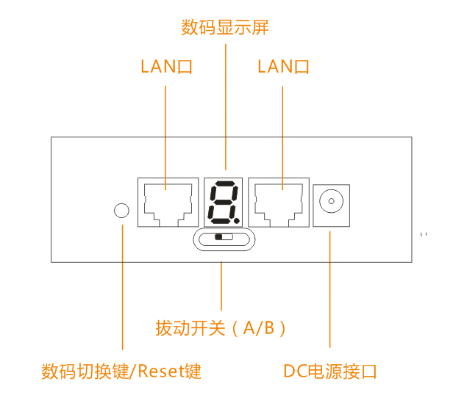
product size
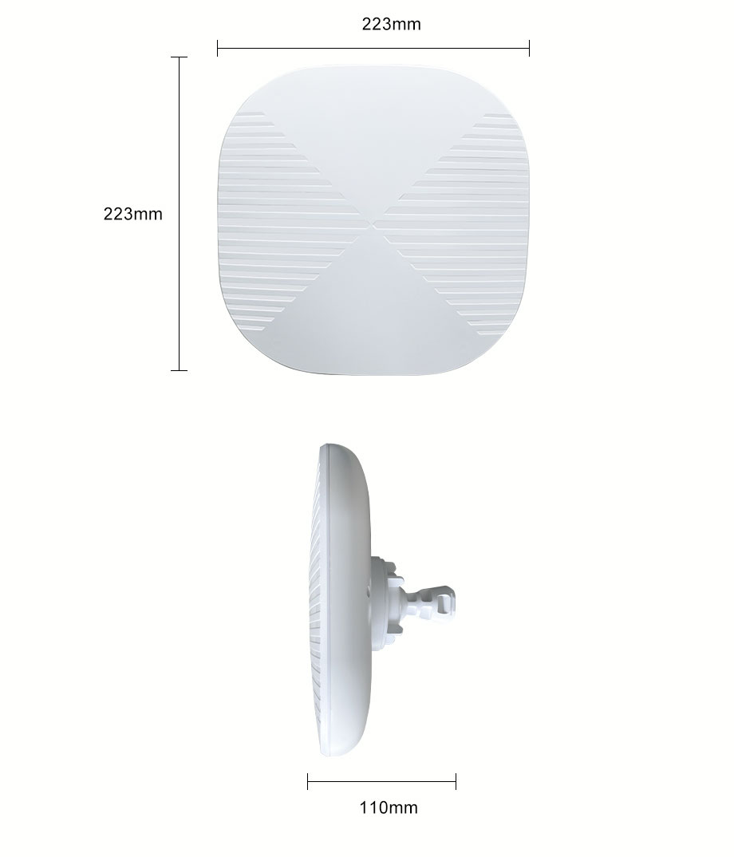

Product Application
I. Point-to-point wireless monitoring transmission applications 1

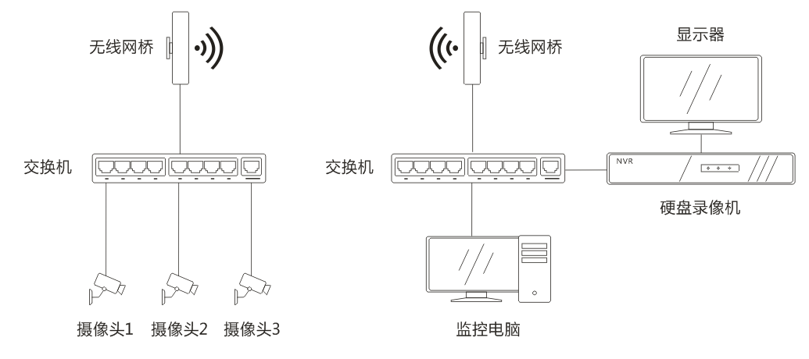

II. Wireless Monitoring Transmission Point-to-Point Applications 2

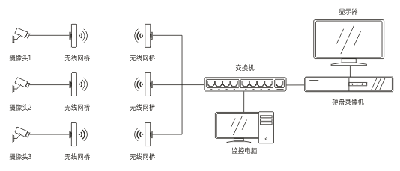

III. Wireless Monitoring Transmission: Point-to-Multipoint Applications 3

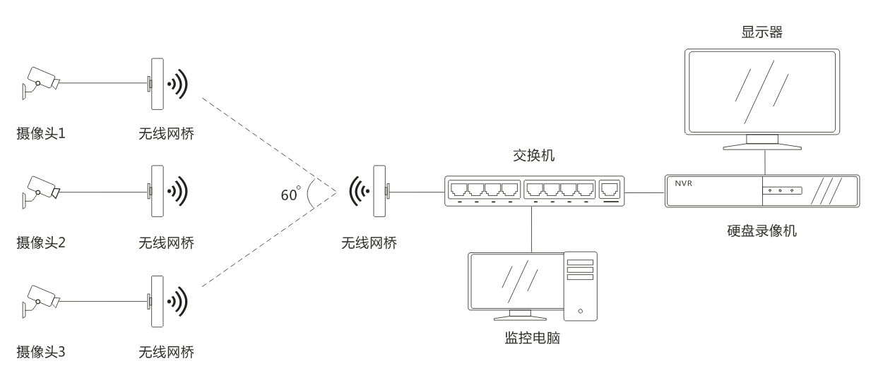

IV. Internet of Things Data Transmission Applications

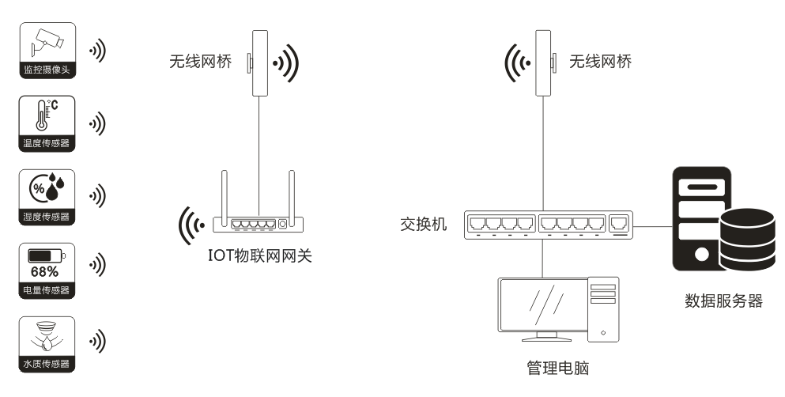

V. Internet Wireless Transmission Applications 1

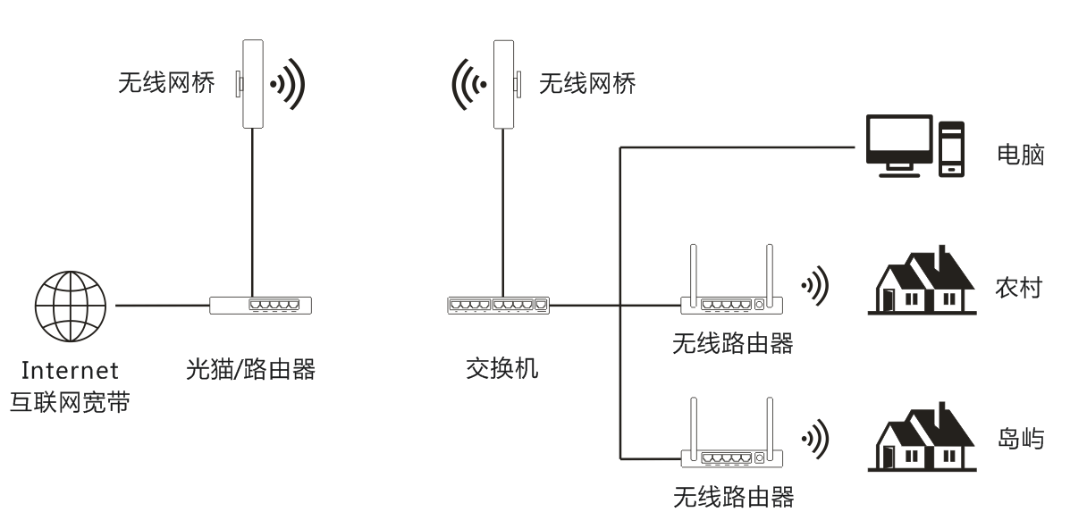

VI. Internet Wireless Transmission Applications 2
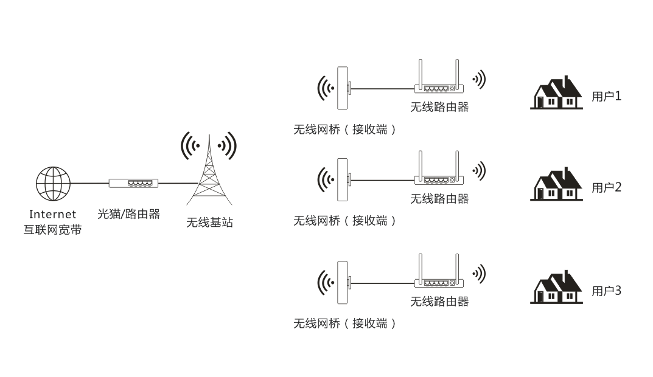

VII. Internet Coverage Applications 3

